
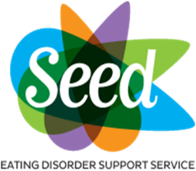
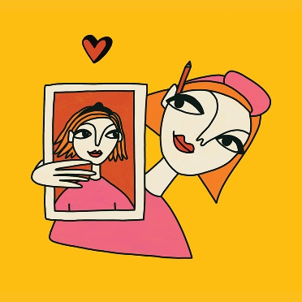

THE ART OF SELF-LOVE
A creative wellbeing course with Sketch Appeal!

Taster sessions:
TUESDAY 10TH AUGUST
Course begins: September
to be arranged

At the taster workshop:

How can drawing self-portraits boost your self-esteem and improve the relationship you have with yourself?

Come and find out at this fun taster workshop led by Dulcie Ball - Founder of Sketch Appeal CIC and Author of The Art Of Self-Love. Dulcie will share her own experience of drawing her way through recovery from anorexia and explain how drawing has helped her to shift her thinking, break free from perfectionism, and to bring lots of joy, fun, and love back into her life.

This will be part presentation and part workshop, so bring your pens/pencils/paper and get set to try out a few fun and easy self-portrait exercises in the second half! No pressure to share your work

NO ARTISTIC SKILLS REQUIRED! Suitable for all – including anyone who thinks they “can’t draw!” (Dulcie will soon prove you wrong!)

THE TASTER SESSION MUST BE BOOKED SEE PAGE 2

On the 6-part course (starting September)

If you enjoy this taster session you will be invited to join a FREE 6-part programme that Dulcie will be hosting for us online. Sessions will delve more deeply into some of the exercises and ideas her book, including making zines, creative visualisation and lots of fun and experimental portraits! In the final week you’ll also get chance to draw each other! The course will be delivered on Zoom and start in September.

LINKS WILL BE PROVIDED ON RETURN OF THE FOLLOWING BOOKING FORM INITIALLY FOR THE TASTER SESSION.

DULCI’S ART TASTER SESSION
10TH AUGUST 2021 deadline for responses 26th July 2021
Name:
Address:
Town/City: |  |  |  |  | Postcode:
Telephone No:
Mobile No:
*E-mail address:
* Will make communication so much easier if you have this. Thank you
I am a: (please tick) |  | Sufferer |  | Carer

Please e-mail your completed booking form to maria@seed.charity

SEED Eating Disorder Support Services – The Resource Room, 267 Beverley Road, Hull HU5 2ST
Admin (01482) 344084 Helpline (01482) 718130 Charity No 1108405
Email hello@seedeatingdisorders.org.uk
Website http://www.seed.charity

